Introduction to Bonds
A bond is a debt security (think of it as a loan). Bonds are issued by governments and corporations. As a holder of a bond, you are entitled to periodic interest payments from the issuer (monthly, quarterly, semi-annually, annually).
A government can issue bonds because it needs a cash flow; it needs money. That’s for a government, but why would a company issue bonds? We said at the beginning of the course that, if a company needs a capital (e.g. to open a new branch, store, factory, etc), it issues shares, so why doesn’t it just issue shares? Sometimes a company doesn’t want more shareholders because, the more the shareholders of a company is, the more the profit is divided among them. So, a company might decide that the current number of shareholders is enough. So, instead, it issues bonds because a bond holder will get his money at the end of the bond period and go away, but a shareholder can be a holder forever. So, why not a company just keeps issuing bonds? Because, on the other hand, bonds are burden on the company because they are debts that must be paid whether the company is doing good or not. If the company goes bankrupt, it must pay bond holders first, and if any money is left, shareholders get theirs.
Following are the common terms that you will come across when looking at bonds (will explain them shortly):
- Face value: the amount received at maturity (also called principal or par value).
- Maturity date: the date by which you get your face value back.
- Coupon rate: the annual interest payment as a percentage of the face value. Notice that the interest payments can be non-annual as we said at the beginning, but the coupon rate is always calculated annually. Also, the coupon rate is fixed until the maturity of the bond (unlike the bond’s price, which can change from time to time depending on interest rates as we will see).
- Price: the market price of the bond. This is also called Net Asset Value (NAV).
- Discount Rate / Market Rate / Yield-To-Maturity (YTM): the interest rate used in the bond pricing formula. It is also the return an investor would make if the bond is held until maturity.
So, what does that mean? To understand bond calculations, you need to understand what “Present Value (PV) of future cash flows” means. If I asked you to lend me $100 and I will give it back to you next year, would you accept that? Of course not, because money loses value over time, so a $100 today won’t worth the same next year. Instead, you should include the interest rate. So, if the interest rate is 5% and you told me that you want to lend $100 and give me back $105 after 1 year, this is okay, it is as if I put my money in a savings account in the bank for 1 year. Now, if I will give you $100 next year, how much would you give me now if the interest rate is 5%?
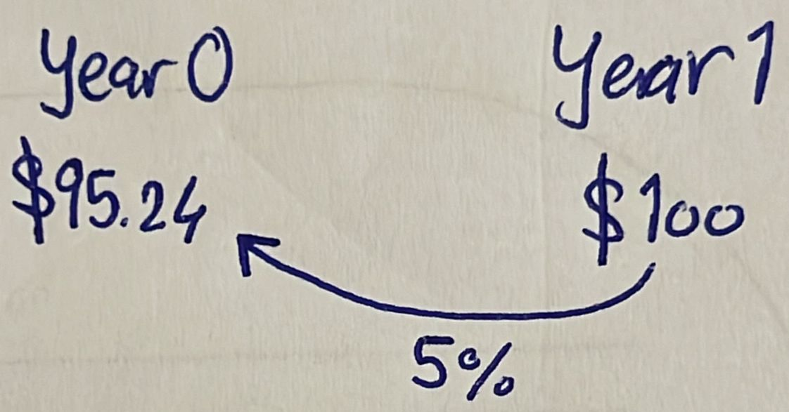
So, $95.24 is called the PV of the $100 future cash flow.
Now, let’s take an example to understand bond calculations. Assume an issuer issued the following bond:
- Face value: $10,000.
- Maturity date: 5 years.
- Coupon rate: 5%.
- Price: $10,000.
- Annual payments.
Let’s break down what this means:
- The issuer wants $10,000 now, which is the bond’s price.
- For 5 years, which is the maturity date, the issuer will pay the bond’s holder 5% x $10,000 = $500 (i.e. coupon rate x face value) every year.
- At the end of the 5th year, the issuer will pay the holder the last $500 coupon we said in the previous point in addition to the face value, which is $10,000.
So, as a bond’s holder, this is what you will pay and get each year:
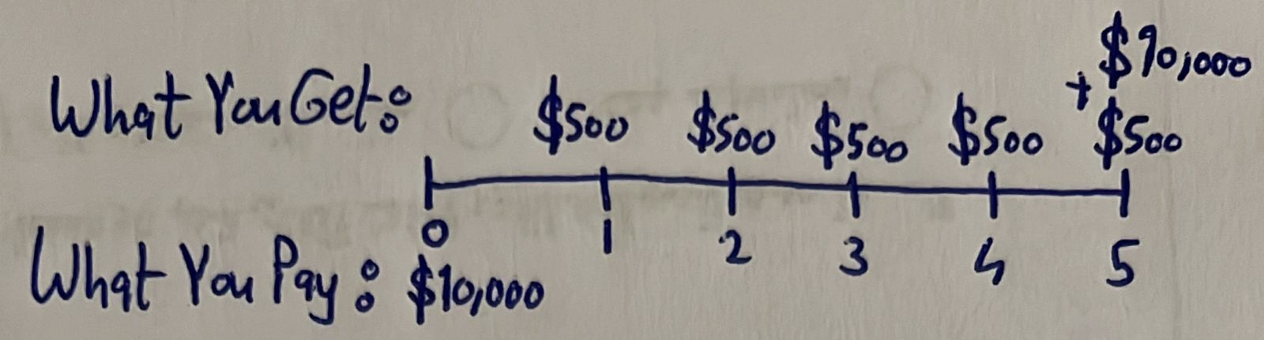
So, as an investor, how do you decide whether this bond is good or not? You must know the interest rate and calculate the bond’s PV! So, assume the interest rate is 5%. This is what is called discount rate, market rate, or YTM. Now, let’s calculate the present value of this bond. We need to calculate the PV of each coupon payment, the PV of the face value, and finally add them all to get the PV of the bond:
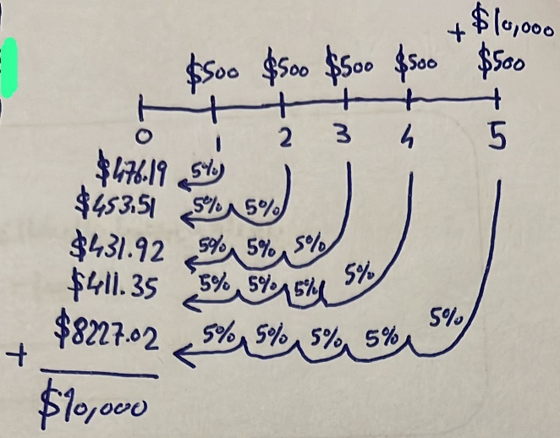
So, the price of the bond is $10,000 and its PV is $10,000 as well. What does this mean? This means that the money you will be getting from the annual coupons of this bond as well as its face value at maturity for the next 5 years is equivalent to $10,000 today, assuming the interest rate is fixed throughout the 5 years. So, you indeed paid $10,000 today to get their equivalent after 5 years assuming the interest rate remains 5% over the next 5 years. This means you bought this bond just to preserve your money against inflation for the next 5 years (assuming inflation rate = interest rate, which is in fact not true), assuming the interest rate remained the same.
But will the interest rate really remain fixed for 5 years? Most probably the Fed will change it to control inflation as we said before. So, let’s study 2 scenarios:
  - Scenario 1: interest rate decreases to 4% immediately after buying the bond
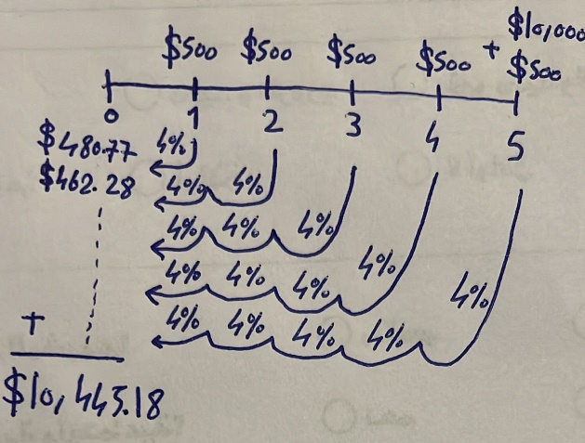
This is perfect, your bond’s PV increased from $10,000 to $10,445.18 after the interest rate dropped from 5% to 4%. This means that you indeed paid $10,000 today to get $10,445.18-worth today after 5 years assuming the interest rate will remain 4% over the next 5 years. So, you are now making a profit in the next 5 years!
So, holding the bond for the next 5 years will guarantee you that your $10,000 will be $10,445.18-worth after 5 years assuming the interest rate is fixed at 4% over the next 5 years. This might be one idea. Another idea is to sell the bond today for $10,445.18. Then? Put those $10,445.18 in another investment that you guarantee that it will get you at least $10,445.18-worth after 5 years. Y3ny eh b2a el kalam da? Enta delwa2ty lama be3t el bond for $10,445.18, fanta delwa2ty m3ak cash $10,445.18, laken lama kan m3ak el bond, kont damen en flosak b3d 5 years hateb2a worth $10,445.18, y3ny kont damen en el $10,445.18 el ba2o m3ak cash delwa2ty will not lose value after 5 years assuming the interest rate will remain fixed. However, el enta 3amalto delwa2ty enak be3t el bond w b2a m3ak el $10,445.18 dool cash, fa lazem tshoof investment tany yedmanlak en el $10,445.18 dool will not lose value in the next 5 years, w ela kont teseeb el bond a7san! Tab howa leeh momken wa7ed yefakar fi tany fekra de? 3ashan definitely madmoon en el interest rate hatefdal sabta le modet 5 years (w fi bonds beteb2a atwal men keda), fa fi nas te7eb enaha to5rog men el bond abl ma el interest rate yezeed tany w te5sar.

  - Scenario 2: interest rate increases to 6% immediately after buying the bond
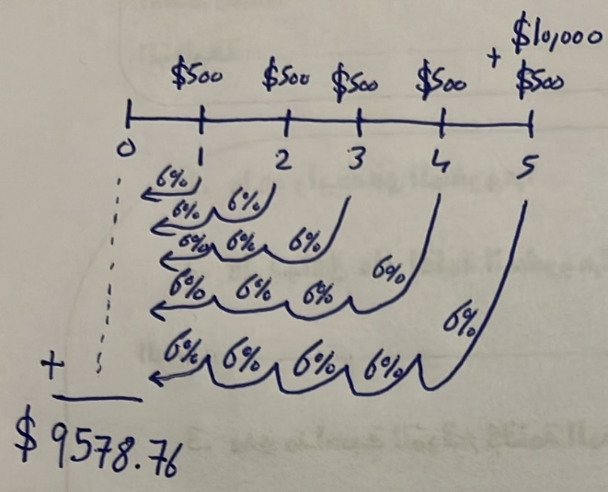
This is bad, your bond’s PV decreased from $10,000 to $9,578.76 after the interest rate increased from 5% to 6%. This means that you indeed paid $10,000 today to get $9,578.76-worth today after 5 years assuming the interest rate will remain 6% over the next 5 years. So, you are now losing money in the next 5 years! It would have been better to just put those $10,000 in a bank’s savings accounts that gives you 6% for the next 5 years, but who knew the bank would increase the interest rate! Now what? If it is expected that the interest rate will increase again soon and remain high most of the bond’s period, then it is better to sell the bond. But if it is expected that the interest rate will decrease soon, then you can hold the bond and wait until then.
Take-home message: if the interest rate goes up, price of bonds will go down. If the interest rate goes down, price of bonds will go up. Accordingly, buy bonds when interest rates are high and expected to decrease soon. Sell your bonds when interest rates are low and expected to increase soon.
Notice that a bond that is being sold at:
- a price equal to its face value is said to be at par.
- a price higher than its face value is said to be at premium.
- a price lower than its face value is said to be at discount.

Bond Types and Risks
Types:
- Government and corporate.
- Short-term bonds: 1 to 4 years.
- Mid-term bonds: 4 to 10 years.
- Long-term bonds: 10 to 30 years.
Risks:
- Default of the issuer: “default” means the issuer not being able to pay back the bond. These are the risk levels: government < corporate < junk. “Junk” are bonds issued by small companies. Of course, the higher the risk, the higher the bond’s interest. You can find websites calling them junk bonds, high-yield bonds, below-investment-grade bonds, and emerging-market bonds.
- Credit quality: people might lose trust in the bond’s issuer. Hence, the credit quality of the issuer can decrease and hence the price of the bond goes down.
- Interest rates: this was clear in the previous examples.

Duration
Bond duration measures the sensitivity of a bond price to the changes in the market interest rate / discount rate / YTM. If a bond duration is 3, this means that:
- If the interest rate goes up by 1%, the bond price will go down by approximately 3%.
- If the interest rate goes down by 1%, the bond price will go up by approximately 3%.
The key factors that affect a bond’s duration:
- Maturity date: the longer, the higher the duration. Think of it in this way: imagine you lend your friend $100. If your friend is to give you back the $100 after 5 days, you don’t really care about the interest rate. But what if your friend will pay you back after 10 years? you will be more affected by interest rate changes. So, the longer the maturity date, the more your bond is sensitive to changes in the interest rate and hence the higher the duration.
- Coupon rate: the larger, the lower the duration. Think of in this way: large coupon rate means that, every year (or whatever), you are getting a large amount of money paid to you on your bond. So, you’re getting your investment returned sooner if the coupon rate is higher. And the sooner you get your money, the less sensitive you are to interest rate changes. Compare a bond with 0% coupon rate to a bond with 100% coupon rate!
Notice that, at the end of the day, the duration is some sort of approximation. So, it has many formulae to be calculated with. The most popular one is Macauley duration. It depends on time-weighting each cash flow until maturity.
Let’s take an example:
Face Value | $1000
Coupon Rate | 10%
YTM | 6%
Maturity Date | 3 Years
First, we calculate the present value:
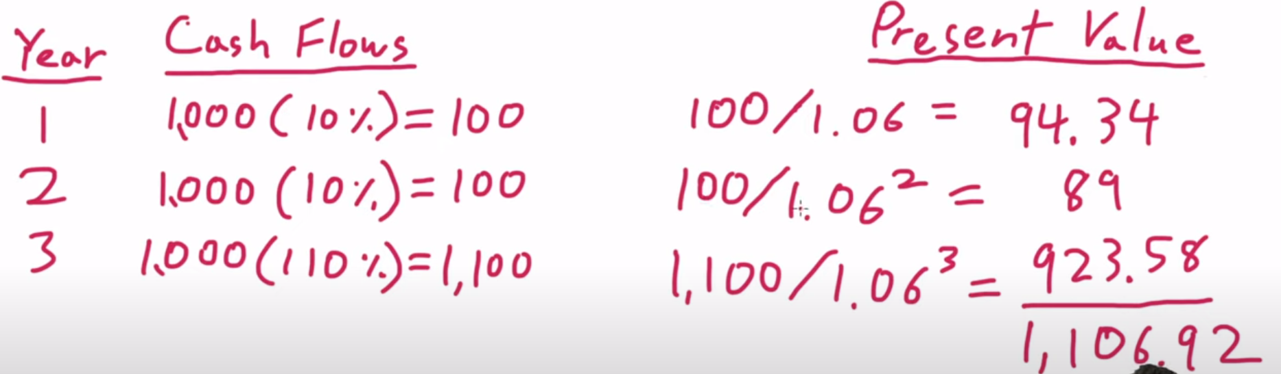
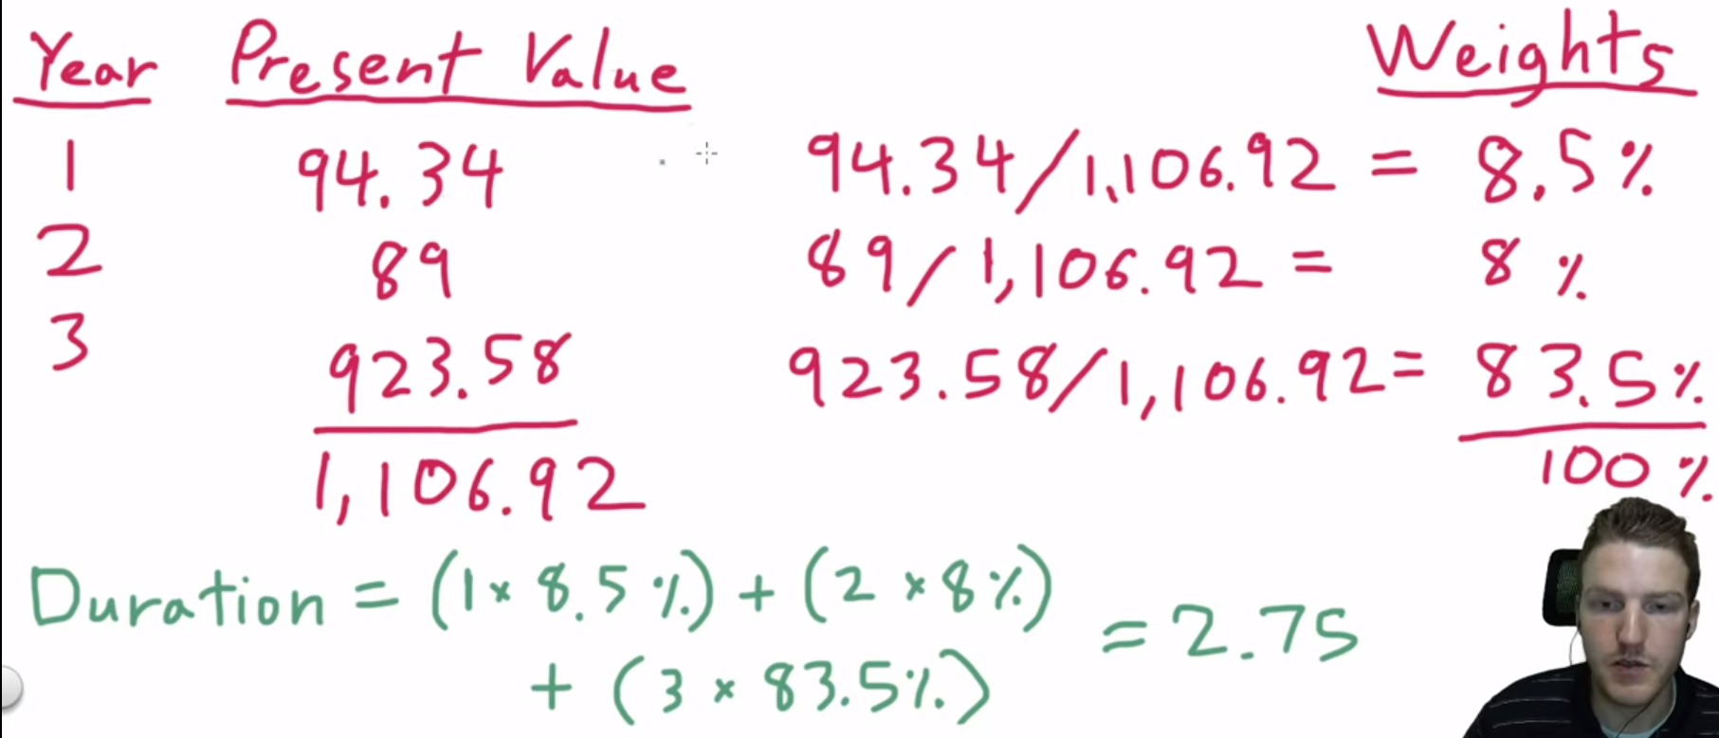
So, assume the interest rate increased by 1% to be 7% instead of 6%. Let’s re-evaluate the bond’s PV:
$$new PV=\frac{100}{1.07}+\frac{100}{{1.07}^{2}}+\frac{1100}{{1.07}^{3}}=\$1078.73$$
The bond’s price dropped from $\$1106.92$ to $\$1078.73$, which is a 2.55% drop. See? The Macauley duration is very close to what really happened.
So, do we want the duration of a bond to be high or low? It depends on the reason why you bought the bond. If you bought the bond thinking that the interest rate would go up, then you wish the duration is high so that your bond’s price significantly goes up when the interest rate increase. On the other hand, if you just bought the bond to make use of it until its maturity, then you wish it doesn’t get affected by interest rate changes. Accordingly, you would wish the duration is low.
Take-home message: long-term bonds are more sensitive to interest rate changes than short-term bonds. low-coupon bonds are more sensitive to interest rate changes than high-coupon bonds.
Note: you can use online calculators to calculate all bond quantities (duration, PV, YTM, etc).
Note: government bonds are sometimes referred to as treasury bills or T-bills.

Why Invest in Bonds
- Periodic payments: some people like to invest in an investment vehicle that gives them periodic returns (e.g. dad likes such an investment vehicle because he has many installments each period, so he would like liquidity every period).
- Stability: many people, especially who are at an age near their retirement, are afraid to get into the stock market since it is too volatile. Instead, they prefer to invest in bonds.
- Diversification: if there was a market crash, all stocks would go down. In this case, bonds are perfect since they won’t go down as much. In such a case, you can even make use of the stock market going down, sell some of your bonds, and buy stocks at low prices! Moreover, during and after the market crash, the government will most probably decrease the interest rate to stimulate the economy, which would make your situation even better and better if you own bonds: you sell it at a higher price since interest rates went down, and you buy stocks at cheaper prices, perfect!

Bond ETFs and Index Funds
If you bought a bond, then you know that it has a maturity date. But when you buy a bond ETF/fund, the ETF/fund just keeps buying bonds again and again, so you are always investing in bonds as long as you hold the ETF or the fund’s certificates. Again, we won’t look at bond mutual funds because bonds don’t generally have big returns, so you surely don’t want to further decrease this small-reasonable return by mutual funds’ high fees.
Shown below are some of the known bond ETFs/index funds. You can search for them on their issuers’ website or etfdb.com for more information:
- BND: Vanguard Total Bond Market ETF / Index Fund. It gives you a mix of government, corporate, as well as other types of bonds.
- LQD: iShares iBoxx $ Investment Grade Corporate Bond ETF. “Investment Grade” means corporates with high credit quality.
- JNK: SPDR Bloomberg Barclays High Yield Bond ETF. It invests in junk bonds.
- BSV: Vanguard Short-Term Bond ETF / Index Fund.
- BLV: Vanguard Long-Term Bond ETF / Index Fund.
- SHV: iShares Short Treasury Bond ETF. This is a government bond.
- IEF: iShares 7-10 Year Treasury Bond ETF. This is a government bond.
- TLT: iShares 20+ Year Treasury Bond ETF. This is a government bond.
Check the chart below. It shows the US interest rate over time. After every disaster, the government reduces the interest rate to stimulate the economy.
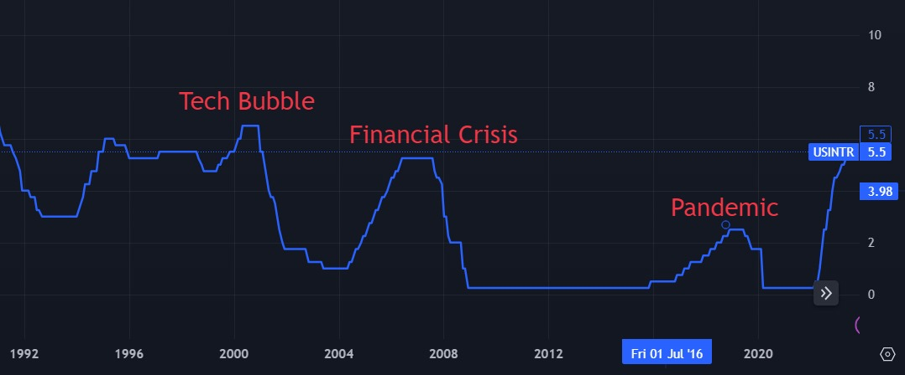
Should you buy junk bonds? Never ever should you buy junk bonds! Why? Because, simply, if you want to invest in something that gives you higher return for higher risk, you can invest in stocks! Check this: shown below is the interest rate and the JNK ETF. During the pandemic, as expected, the US government reduced the interest rate to stimulate the economy. So, it is expected that the bonds prices go up, right? Look what happened to the JNK ETF, it crashed with the market! Why did this happen although the interest rate went down? Because a bond doesn’t only depend on the interest rate, but only on the credit quality of the issuer. And during the pandemic, people had no trust that the low-grade corporates would be able to pay their bonds, this is why the junk bonds deteriorated with the stock market. So, there is really no point in buying junk bonds. On the other hand, let’s look at government bonds that people have trust in. Let’s compare between the SHV, IEF, and TLT government ETF bonds and JNK. Shown below is USA interest rate in yellow, SHV in dark blue, IEF in orange, TLT in light blue, and BND in purple. Look how SHV is stable even during the pandemic. This is because it is a short-term bond as well as the US government has good credit quality. IEF is more sensitive compared to SHV since it is an intermediate-term bond, and TLT is the most sensitive one since it’s a long-term bond. However, none of them decreased during the pandemic because the government has good credit quality and the interest rate went down, so they went up. None of them went down like the JNK bond.
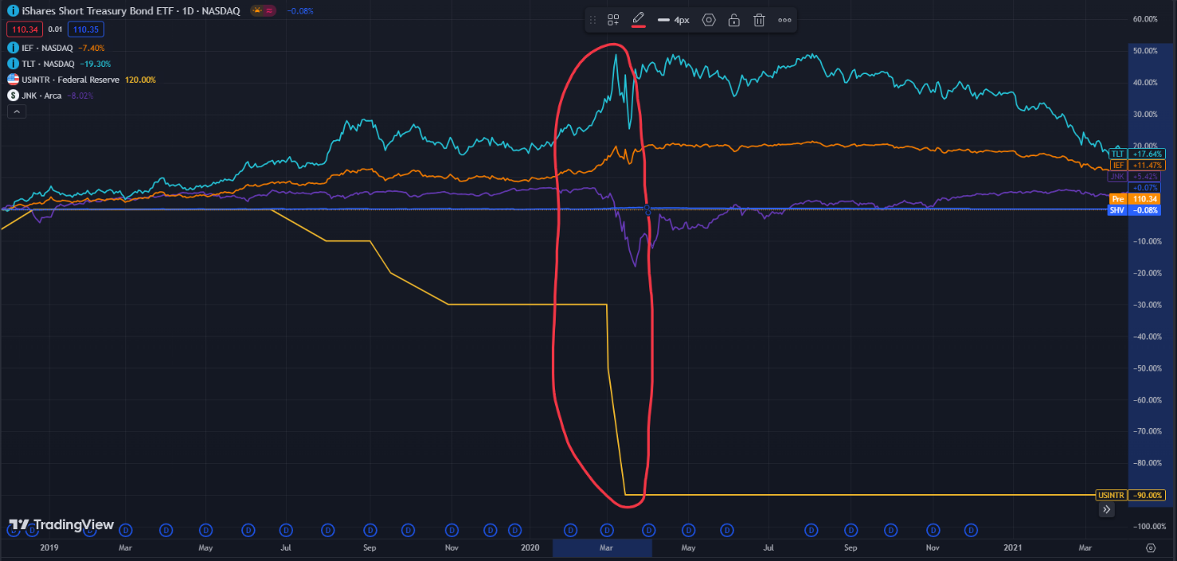
So, your bond’s price is affected by interest rate, credit quality, and its maturity date. If you want to eliminate the credit quality from your calculations, just stick to government bonds. Now, you are left with only interest rate and maturity date. The longer the maturity date, the higher the duration of your bond and hence the higher its sensitivity to interest rates. The shorter the maturity date, the less sensitive your bond is to the interest rate changes. This is very clear in the previous chart: SHV is not affected at all by interest rates, IEF is more sensitive, and TLT is more and more sensitive. So, this is what you can do:
- Buy short-term US government bonds regularly to protect your money against inflation. This part of your portfolio will the safest, yet the least profitable. It is as if you are protecting the money you are putting in this type of bonds against inflation, which is not a bad idea.
- Buy long-term US government bonds during high-interest-rate periods and sell them when the interest rate goes down. However, you should know that you are taking more risk here because the interest rate might remain high or even increase. In this situation, to decrease the risk, you can do DCA; buy long-term bonds regularly as long as the interest rate is either going up or fixed. Then, once the interest rate goes down, you sell. Of course, the closer you buy bonds before interest rates go down, the better. That is, it would have been perfect if you’ve done a lump sum at the red-circled regions shown below:
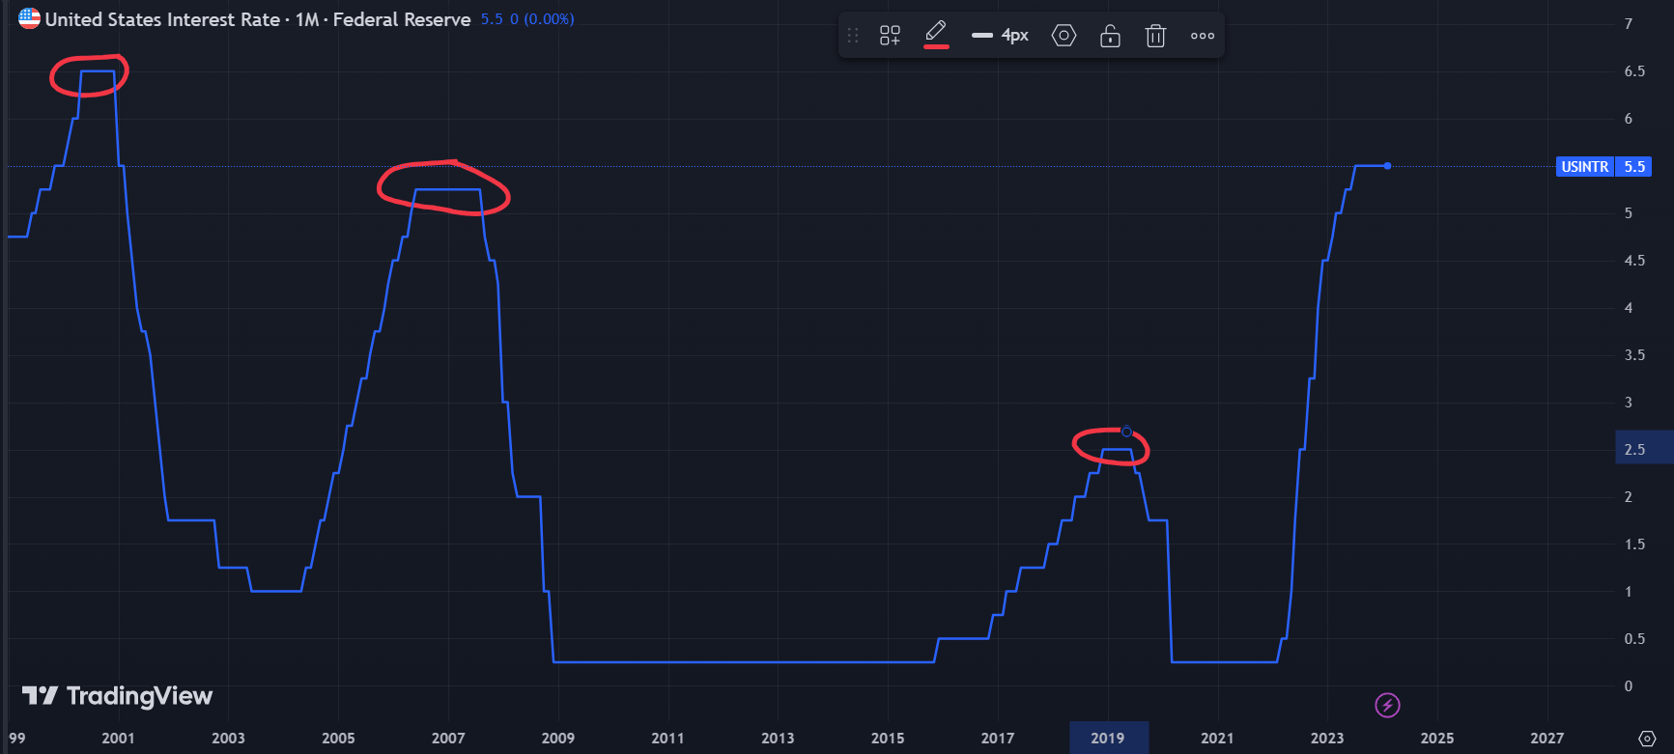
Look what happened below shortly after the interest rates went down in these periods in the price of the TLT ETF (which is a long-term US government bond). The ETF’s price went up significantly! Also, notice that, shortly after the interest rates were fixed again (in around 2009 and at the middle/end of 2020), the bond’s price began to drop again. So, in order to really make a good investment using a long-term bond, you need to time the market: you need to buy when the interest rate is fixed and is expected to go down, then sell just before the interest rate gets fixed. This is why long-term bonds are more risky.
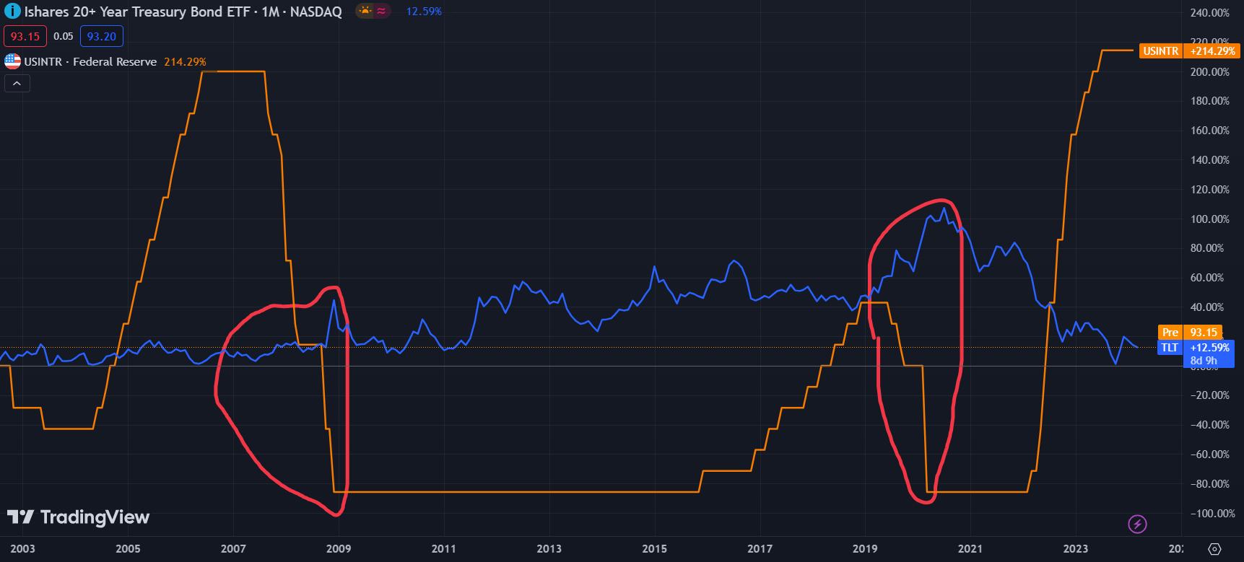
So, a bond ETF or a bond index fund? Generally, Mohsen Hassan prefers ETFs to funds because an ETF is like a stock, you can sell it at any time and buy something else. On the other hand, in an index or mutual fund, your order is neither placed nor executed immediately, it usually takes some days to get your money back. Since Mohsen Hassan is an active trader, he prefers ETFs. Accordingly, if there is a good deal and you just want to sell your index/mutual fund certificates immediately (e.g. the current price of the index/mutual fund certificate is high or you want to buy something else at super cheap price), you won’t be able to do so.
Notice that, during the pandemic, there was a problem (seems a sophisticated one to understand) regarding investment-grade corporate (i.e. not government bonds) ETFs / index funds that caused its price to go down although it is expected to go up (because people believe investment-grade corporate bonds are as safe as government bonds since big companies have good credit quality as the government). Such a problem happened only during the pandemic market crash and never happened again in history. You can read more about the problem here. This is clear from the chart given below: it compares the long-term US government bond ETF TLT to the long-term investment-grade corporate bond ETF VCLT during the pandemic. Notice how VCLT went down significantly. It is as if it crashed with the market although it was expected to go up.
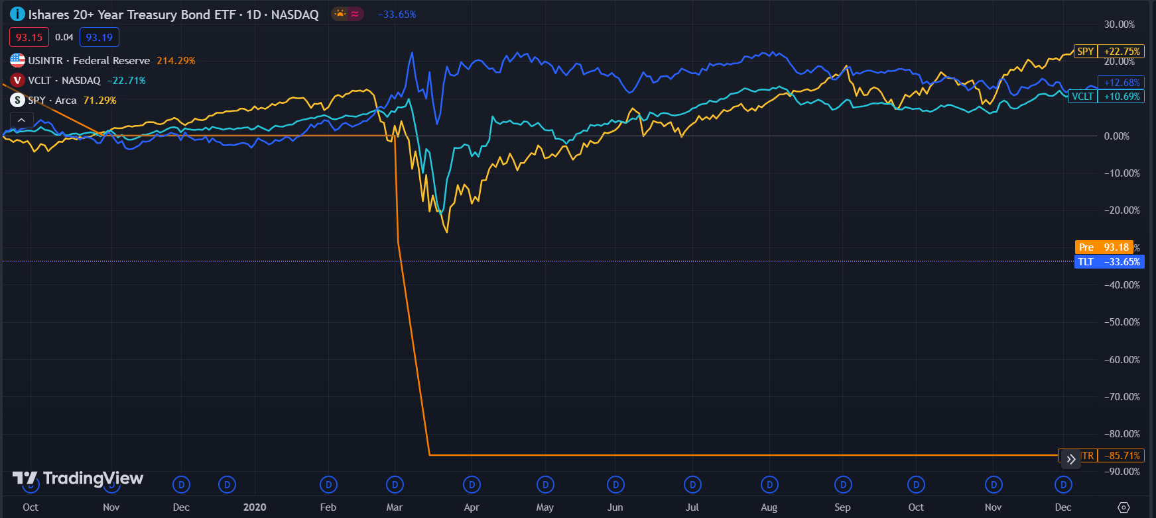
This happened even with short-term bonds, which were always considered very stable! The chart below compares the US government short-term bond ETF SHV (in blue) to the investment-grade short-term bond ETF VCSH (red). Look how steady SHV is during the pandemic compared to VCSH, which dropped with the market!
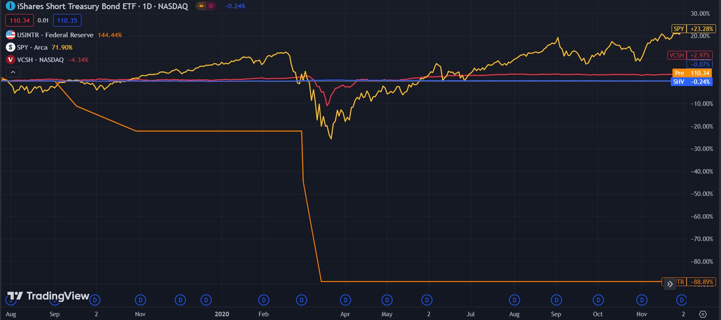
So, the take-home message from this problem is: even investment-grade corporate bonds can be riskier compared to government bonds US government bonds are always the safest type of bonds!

Bonds vs Bond ETFs & Funds
Should we directly buy bonds or buy bond ETFs / index funds instead? Let’s see the advantages and disadvantages of directly holding a bond rather than buying a bond ETF / index fund.
Advantages:
- You know exactly how much you’ll be getting if you hold the bond to maturity. When you buy a bond, you know the face value you will be getting at the end of the period, its maturity date, and the coupons you will be getting every period. Even if the interest rate changed, okay your bond’s price would fluctuate, but this is only if you sold it! If you kept it until maturity, you will be getting the same coupons as well as face value at the end.
- Return of principal: if you hold a bond, you know you will be getting a principal at maturity. However, when investing in a bond ETF / index fund, the ETF/ index fund holds many bonds, and when one matures, it buys another one. So, the ETF / index fund always constitutes bonds, so it is as if you are investing in bonds that are maturing at infinity, so you will never get a principal!
- Return of fixed periodic income: a bond has a fixed coupon rate, so you’re certain that you’ll be a fixed income each period. On the other hand, since a bond ETF / index fund invests in many bonds, okay it will be paying a dividend each period, but this dividend won’t be fixed. Why? Because the ETF / fund constitutes many different bonds with different coupon rates and maturity dates (especially corporate ETFs/funds), so the return is never fixed.
Disadvantages:
- Requires more capital: a lot of bonds might cost around $5,000 to $20,000 to buy. And for someone who doesn’t have a big capital, he wouldn’t be able to afford buying a bond. Or, he might be able to afford it, but being expensive would cause his portfolio not to be diversified as he wishes; bonds might constitute a large percentage of his portfolio. On the other hand, you can buy a bond ETF as cheap as $100!
- Less diversification: assume the bonds available for you cost $10,000 each. If you have only $20,000 to put in bonds, you will buy only 2 bonds (e.g. 1 Apple bond and 1 Google bond). Compare this to someone who invested in a bond ETF / index fund that holds many different corporate bonds. Notice that this is a disadvantage only if you are to invest in corporate bonds. But if you intend to buy only government bonds, this won’t be a disadvantage for you, but you would get less return.
Mohsen Hassan’s advice:
- Bond ETFs/funds are good for young people since such ETFs/funds are cheaper. Also, such young people are willing to take more risk since bond ETFs/funds are more volatile than bonds (since bond ETFs/funds constitute many bonds).
- Bonds are good for old people since they are less volatile. Also, such old people can easily afford the expensive prices of bonds.

